Билеты для магистрантов

Раздел 1

1. Look at the diagram and state what kind of corporate structure they are.

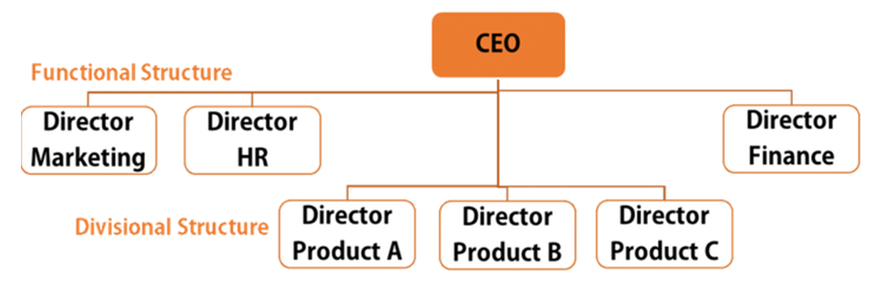

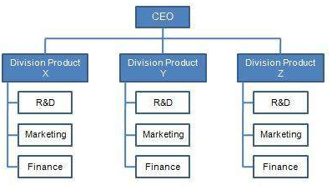
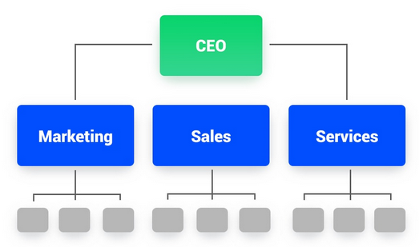

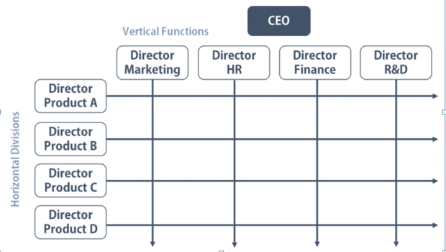

2. Read the summary of an article and state which is the introduction sentence, supporting arguments, and the final point
- In addition, Jones points out that most professional runners use Nike and he tells his own story of how he won the 100-meter men's competition after switching to Nike shoes.
- In “My Favorite Shoe,” Treyvon Jones explains that Nike shoes are the best brand of running shoe for serious track athletes.
- Jones supports this view by pointing out that Nike shoes are more comfortable, last longer, and provide more cushioning for the feet.
- He notes that the statistics from sales and scientific evidence of how Nike shoes are better for the feet support his claim.
3. What are the standard elements of citations?
4. What must be cited in your graduate dissertation?
5. How can you avoid plagiarism in your graduate dissertation?
6. What are the main elements of a research paper?
7. What are the main elements of planning a research project?
8. What are the main stages of describing a process/ process diagram?
9. Why do institutions and publishers generally require writing in the third person (neutral style)?
10. When and how are poster presentations used?

Раздел 2a
1. Speak about an innovation in your professional field. Use 3-5 sentences.
What kind of innovation is it? How does it work?

2. Speak about an innovation in your professional field. Use 3-5 sentences.
What kind of innovation is it? What are the advantages of this innovation over existing analogues?

3. Speak about an innovation in your professional field. Use 3-5 sentences.
What kind of innovation is it? What are its future developments/ prospective uses?

4. Speak about an innovation in your professional field. Use 3-5 sentences.
What kind of innovation is it? Describe how it works.

5. Speak about an innovation in your professional field. Use 3-5 sentences.
What kind of innovation is it? What are its innovative features?

Раздел 2b
1. Speak about your dissertation. What is the goal of your research? Use 3-5 sentences.

2. Speak about your dissertation. What is the rationale of your research? Use 3-5 sentences.

3. Speak about your dissertation. What are the objectives of your research? Use 3-5 sentences.

4. Speak about your dissertation. What methods will you use to reach the goal and objectives of your research? Use 3-5 sentences.

5. Speak about your dissertation. What problem does your research solve? Use 3-5 sentences.

